**Continuing Education Activity Plan**  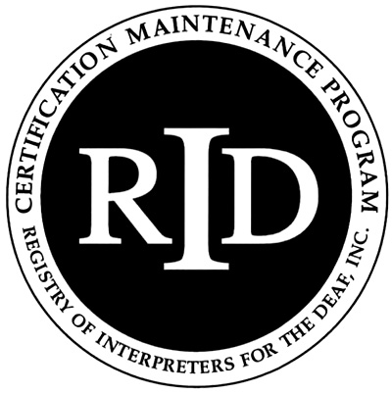

**Sponsor Form**

It is recommended, but not required, that this activity be submitted ONLINE at myaccount.rid.org at least 30 days prior to the start of the activity. A copy of this form along with the Activity Plan Instructor’s form must be kept on file for future auditing purposes.

Name of Approved Sponsor: Click here to enter text.

Activity Number: Click here to enter text. . Click here to enter text. . Click here to enter text.

(Sponsor Code) . (MonthYear) . (Ascending within month)

Activity Title: Click here to enter text.

Location of Activity: Click here to enter text.(City) Click here to enter text. (State)

Instructor(s) Name(s): Click here to enter text.

Contact Person/People: Click here to enter text. Contact Phone(s):Click here to enter text.

E-mail Click here to enter text. Web site: Click here to enter text.

Who is the Target Audience: Click here to enter text.

Activity Start Date: Click here to enter a date. Activity Completion Date: Click here to enter a date.

Start Time for Activity: Click here to enter text.am/pm Ending Time for Activity: Click here to enter text.am/pm

Total number of CEUs to be awarded to each participant: Click here to enter text. =========================================================================== **Content Area: Content Level: Participating Programs:**

Professional Studies (PS) Little/none CMP only

General Studies (GS) Some ACET only

Extensive CMP & ACET Both

Teaching

As the RID Approved Sponsor for the RID activity, I certify that the above information is accurate and will be filed ONLINE with RID through [myaccount.rid.org](http://www.rid.org) prior to the start of the activity.

RID Approved Sponsor Signature Administrator: Click here to enter text. Date: Click here to enter a date.

**Updated April 2016**